

SecureGrade: A Tamper-Resistant Digital Grade Vetting and Approval System

Ghulam Ishaq Khan Institute of Engineering Sciences and Technology

Secure Software Design
CY321

Bushra Naz 2022140
Mahnoor Omer 2022912
Shariq Saqib

Project Overview

The Secure Digital Grade Vetting System is a web-based platform designed to provide a secure and transparent workflow for the submission and approval of academic grades within a university environment. Traditional digital grading systems often lack sufficient mechanisms to prevent unauthorized modifications, track changes, or ensure accountability among faculty members responsible for submitting and approving grades. These weaknesses may lead to grade manipulation, disputes, or loss of trust in the integrity of the academic evaluation process.
The proposed system introduces a structured and secure grade management workflow in which instructors submit final course grades through a secure interface. Each grade submission is associated with the instructor’s identity and digitally signed to ensure authenticity and integrity. Once submitted, the grades enter a verification stage where they must be reviewed and approved by the Head of Department (HoD) before becoming finalized records. This multi-stage approval workflow ensures that submitted grades undergo oversight and cannot be finalized without proper authorization. To maintain the integrity and transparency of the grading process, the system incorporates multiple security mechanisms including role-based access control (RBAC), cryptographic digital signatures, and tamper-resistant audit logs. These features ensure that only authorized personnel can perform sensitive operations, that grade submissions cannot be modified without detection, and that all actions within the system are traceable to specific users. By integrating these security controls into the software design, the system aims to improve the reliability, accountability, and security of digital grade management within academic institutions.

Security Requirements

The Secure Digital Grade Vetting System incorporates a set of security requirements to ensure that sensitive academic records remain protected from unauthorized access, modification, or misuse. These requirements are categorized into functional security requirements, which describe security-related system features, and non-functional security requirements, which define the overall security properties the system must maintain.

Functional Security Requirements
- User Authentication
The system must require all users to authenticate before accessing the platform. Secure authentication mechanisms will be implemented, and user passwords will be stored using cryptographic hashing techniques such as bcrypt to prevent credential compromise.
- Role-Based Access Control (RBAC)
The system must enforce role-based permissions to restrict actions according to user roles. Instructors are allowed to submit grades, the Head of Department can review and approve submissions, and administrators are responsible for managing user accounts and system roles.
- Digital Signature for Grade Submission
Each grade submission must be digitally signed by the instructor to ensure authenticity and integrity. The system must verify the digital signature before allowing the submission to proceed to the approval stage.
- Secure Approval Workflow
Grade submissions must follow a structured approval process where only authorized HoD users can approve or reject submissions before they become finalized records.
- Audit Logging
The system must record all critical actions, including grade submissions, approvals, rejections, and administrative changes, in a secure audit log. These logs should include timestamps and user identifiers to ensure accountability.
- Input Validation and Data Integrity Checks
All inputs submitted to the system must be validated to prevent malicious inputs and injection attacks. Additionally, cryptographic hashing will be used to verify that stored grade data has not been modified without authorization.

Non-Functional Security Requirements

- Confidentiality
Sensitive data, including grade records and user credentials, must be protected through encrypted communication channels (HTTPS) and secure storage mechanisms.
- Integrity
The system must ensure that grade records cannot be modified without detection. Digital signatures and cryptographic hashing mechanisms will be used to maintain data integrity.
- Availability
The system should remain accessible during critical periods such as final grade submissions. Protective measures such as rate limiting and monitoring mechanisms will be implemented to mitigate denial-of-service attacks.
- Non-Repudiation
Users must not be able to deny actions they performed within the system. Digital signatures and secure audit logs will provide verifiable evidence of user actions.
- Accountability and Traceability
All significant actions within the system must be traceable to authenticated users through audit logging mechanisms.

Risk Management Table (STRIDE-Based Assessment)

Risk Score Calculation: Risk Score = Likelihood × Impact
Likelihood: Low=1, Medium=2, High=3
|Impact: Low=1, Medium=2, High=3

Risk ID | STRIDE Category | Threat | Description | Likelihood | Impact | Risk Score | Risk Level | Security Controls / Mitigation
R1 | Spoofing | Instructor Identity Spoofing | Attacker impersonates instructor and submits fraudulent grades. | Medium (2) | High (3) | 6 | High | JWT authentication, MFA login, strict role validation
R2 | Spoofing | HoD Session Hijacking | Stolen HoD session used to approve or reject grades. | Medium (2) | High (3) | 6 | High | HTTPS secure cookies, short session tokens, device/IP verification
R3 | Tampering | Grade Submission Tampering | Grade data modified during transmission before signing. | Low (1) | High (3) | 3 | Medium | TLS encrypted transport, input validation, integrity checks
R4 | Tampering | Database Grade Modification | Unauthorized user changes | Low (1) | High (3) | 3 | Medium | Database encryption (AES-256), strict
 |  |  | stored grades in database. |  |  |  |  | DB access control
R5 | Tampering | Audit Log Manipulation | Attackers modify audit logs to hide grade changes. | Low (1) | High (3) | 3 | Medium | Immutable logging, append-only storage, cryptographic log chaining
R6 | Repudiation | Instructor Denial of Submission | Instructor denies submitting or signing grades. | Low (1) | Medium (2) | 2 | Low | Digital signatures, timestamped audit logs
R7 | Repudiation | HoD Denial of Approval | HoD denies approving or rejecting grades. | Low (1) | Medium (2) | 2 | Low | Approval logs with identity, IP, timestamp
R8 | Information Disclosure | Unauthorized Grade Access | Unauthorized users gain access to student grade records. | Medium (2) | High (3) | 6 | High | RBAC enforcement, encrypted database storage
R9 | Information Disclosure | Data Interception | Grade data intercepted between frontend and backend. | Medium (2) | Medium (2) | 4 | Medium | TLS 1.3 encryption, HTTPS secure APIs
R10 | Information Disclosure | Audit Data Exposure | Sensitive logs accessed by unauthorized staff. | Low (1) | Medium (2) | 2 | Low | Restricted log access using RBAC
R11 | Denial of Service | Grade Submission Flooding | Attackers overload grade submission endpoints. | Medium (2) | Medium (2) | 4 | Medium | API rate limiting, traffic monitoring
R12 | Denial of Service | Authentication Flooding | Repeated login attempts degrade system availability. | Medium (2) | Medium (2) | 4 | Medium | CAPTCHA, login monitoring, account lockout
R13 | Elevation of Privilege | Student Privilege Escalation | Student gains instructor permissions. | Low (1) | High (3) | 3 | Medium | RBAC enforcement, admin-controlled role assignment
R14 | Elevation of Privilege | Instructor Privilege Abuse | Instructor attempts to approve their own submitted grades. | Low (1) | High (3) | 3 | Medium | Separation of duties policy
R15 | Elevation of Privilege | Admin Account Compromise | Attacker gains control of administrator account. | Low (1) | High (3) | 3 | Medium | Admin MFA, dual-admin approval for role changes

Threat Modeling Table (STRIDE)

The following table applies the STRIDE threat model to the SecureGrade system based on the provided Level-1 Data Flow Diagram (DFD). Each STRIDE category is mapped to potential threats affecting system processes, actors, data stores, and data flows. The table also identifies risk levels and recommended mitigation controls.
STRIDE Key
S = Spoofing | T = Tampering | R = Repudiation | I = Information Disclosure | D = Denial of Service | E = Elevation of Privilege
STRIDE | Threat Example | Component / Actor | Risk Level | Mitigation / Control
S – Spoofing | Attacker impersonates an Instructor to submit fraudulent grades | P1 Grade Submission / Instructor | High | JWT authentication with MFA; short-lived session tokens; server-side role validation before grade submission.
S – Spoofing | Stolen HoD session used to approve grades | P4 Approval / HoD | High | Signed JWT tokens, HTTPS-only cookies, IP/device verification, re-authentication before approval.
T – Tampering | Grade data altered during submission before signing | P1 Grade Submission | High | Input validation, TLS encrypted transport, integrity checks before signing.
T – Tampering | Unauthorized modification of stored grades | D1 Grade Database | High | AES-256 encryption at rest, strict database access control, integrity verification using stored hash.
T – Tampering | Audit logs modified to hide grade changes | D2 Audit Log Storage | Low | WORM immutable log storage, append-only access, cryptographic log chaining.
R – Repudiation | Instructor denies submitting or signing grades | P2 Grade Signing / P5 Audit Logging | Medium | Digital signatures (SHA-256 + DSA) and timestamped audit records stored in immutable log.
R – Repudiation | HoD denies approving or rejecting grades | P4 Approval / D2 Audit Log | Low | Approval actions logged with identity, timestamp, IP, and session fingerprint.
I – Information Disclosure | Unauthorized access to student grades | D1 Grade Database | High | RBAC enforcement, encrypted database, restricted backend access.
I – Information Disclosure | Grade data intercepted during transmission | Frontend ↔ Backend API | Medium | TLS 1.3 encryption, HSTS headers, secure API gateway.
I – Information Disclosure | Sensitive audit data exposed to unauthorized staff | D2 Audit Log Storage | Medium | Audit logs restricted to Admin roles via RBAC; anonymized sensitive data.
D – Denial of Service | Attackers flood the grade submission endpoint | P1 Grade Submission | Medium | API rate limiting, request throttling, automated blocking of abusive IPs.
D – Denial of Service | Repeated login attempts lock out legitimate instructors | Authentication Layer | Medium | Account lockout policies, CAPTCHA after repeated failures, login monitoring.
E – Elevation of Privilege | Student gains Instructor privileges to submit grades | P6 User Role Management / D3 Role Database | High | Admin-controlled role assignment, RBAC enforcement, audit logging of role changes.
E – Elevation of Privilege | Instructor escalates privileges to HoD and approves own grades | P4 Approval / P6 Role Management | High | Separation of duties policy; instructors cannot approve grades they submitted.
E – Elevation of Privilege | Compromised admin account grants excessive roles | P6 Admin / D3 Role Database | Medium | Mandatory MFA for admin accounts, dual-admin approval for privilege changes, continuous audit review.

Risk Level Legend
Risk | Meaning
High | Severe impact — must be addressed in system design
Medium | Moderate impact — mitigated with standard security controls
Low | Minor impact — monitor and review

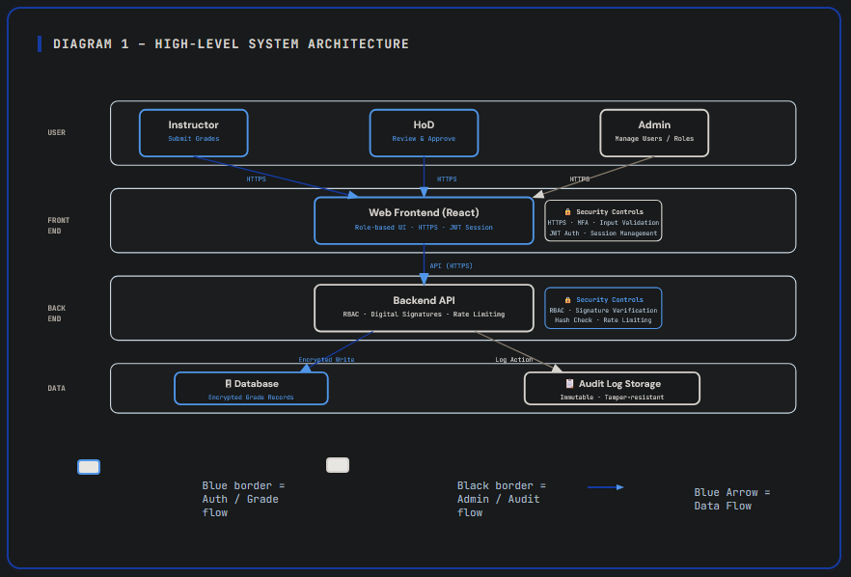
SYSTEM ARCHITECTURE DIAGRAM

DATA FLOW DIAGRAM
